

**This document provides essential information to the investors of this Collective Employee Shareholding Fund (French *Fonds Commun de Placement d’Entreprise*, hereinafter referred to as “FCPE”). This is not a promotional document. The information contained herein is provided to you as required by law, in order to help you understand what investing in this FCPE means and what risks are associated with it. It is hereby recommended that you read it in order to make an informed decision on whether or not to invest.**

## MULTI ASSET CLIENT SOLUTIONS

AXA Plan 2019 Global (CODE AMF: 990000122659)

Compartment of the FCPE Shareplan AXA Direct Global Category of units: Capitalized in Euros

This FCPE is managed by AXA IM Paris, a subsidiary of the AXA IM Group

*Fonds Commun de Placement d’Entreprise* (French Collective Employee Shareholding Fund or “FCPE”) *- Fonds d’Epargne Salariale* (French Employee Savings Fund) governed by French law

Investment Objective and Policy

The FCPE belongs to the following category: “Formula” FCPE

FCPE offering guaranteed capital at expiration

**Management objective:**

The management objective of this FCPE, which was created in the context of the capital increase reserved for participants of the Group Company Savings Plan and the International Group Shareholding Plan, dated November 29, 2019, is to offer each unitholder (before tax, social security, or any other assimilated withholdings), at expiration (i.e. on July 1, 2024, also referred to as the “International Final Reference Date”) as well as in exceptional cases of early exit provided for by law, on each valuation date, a “Guaranteed Net Asset Value” corresponding to an amount per unit subscribed that is equal to:

● his or her personal contribution per unit (equal to the subscription price of an AXA share (hereinafter referred to as the “Subscription Price”), which corresponds to the arithmetic average of the 20 daily VWAPs (“Volume-Weighted Average Prices” corresponding to the volume-weighted average of the share prices traded on the French stock exchange on a given trading day, excluding opening and closing fixings) of the AXA share (hereinafter referred to as the “Share”) preceding October 15, 2019 (referred to as the “Reference Price”) after applying a 4.99 % discount), plus

● a performance (hereinafter referred to as the “Performance”) equal to a variable performance multiple (hereinafter referred to as the “Variable Multiple”) times the increase in the price of the Share, it being understood that this Variable Multiple is equal to 7.5 (or a leverage of 10 multiplied by 75% (hereinafter referred to as the “Participation Percentage”)) times the ratio between (i) the Reference Price and (ii) the sum of (a) 0.5 times the Final Share Price or Interim Share Price, as the case may be, plus (b) 0.5 times the Reference Price, and that the increase in the price of the Share is assessed on the basis of the difference, if positive, between an average share price (Interim Share Price or Final Share Price, as the case may be) and the Reference Price (in other words the non-discounted price). The Performance is considered equal to zero in the event that this difference is negative or equal to zero.

|  |  |
| --- | --- |
| **ADVANTAGES** | **DISADVANTAGES** |
| The unitholder benefits from:   * a leverage mechanism (hereinafter referred to as the "Leverage Mechanism"), or in other words the ability, via the FCPE, to subscribe a number of Shares that is ten times that which he or she could have subscribed using his or her personal contribution only; * the guarantee on the value of his or her personal contribution at expiration and in exceptional cases of early exit, and   - the Performance multiplied by the number of units, the Performance being defined as the Variable Multiple times the potential increase in the price of the Share, the latter corresponding to the difference, if positive, between the Interim Share Price or (as the case may be) the Final Share Price and the Reference Price | In the event that the price of the Share does not increase, the unitholders will not receive any amount as Performance.  In exchange for a guarantee on their personal contribution and for the Performance, if any, the unitholder waives his or her right to benefit from:  - the 4.99 % discount applied to all of the Shares subscribed by the FCPE;  - a portion of the potential increase in the price of the Shares, corresponding to the product of (i) the difference, if positive, between the Interim Share Price or (as the case may be) the Final Share Price and the Reference Price, and (ii) the difference between the leverage of 10 and the Variable Multiple;  - the potential dividends and other financial rights or entitlements intended for shareholders (for further details please refer to the Regulations of the FCPE). |

In addition to benefiting from a guarantee on the value of his or her personal contribution, each unitholder will benefit from the Performance, in other words from the increase in the price of the Share compared to the Reference Price multiplied by the Variable Multiple. The latter is variable in that its value decreases depending on the evolution of the price of the Share. As such, the higher the increase in the price of the Share compared to the Reference Price, the lower the value of the Variable Multiple will be. However, as the price of the Share increases, the Performance, and therefore the Guaranteed Net Asset Value, also increases.

The “Final Share Price” corresponds to the arithmetic average of the 52 closing share prices recorded each week as from June 14, 2023 (inclusive). The “Interim Share Price” corresponds either to the arithmetic average of 3 closing share prices in the event of early exit prior to June 14, 2023, or to an average share price taking into account the closing share prices recorded on a weekly basis for the purpose of calculating the Final Share Price in the event of an early exit between June 14, 2023 and July 1, 2024. The Final Share Price and the Interim Share Price are defined in further detail in the Regulations of the FCPE.

The Reference Price and the Participation Percentage can be adjusted (upwards or downwards) in accordance with the conditions described in the Regulations of the FCPE, in order to maintain an economic balance between the FCPE and NATIXIS under the terms of the International Swap Agreement mentioned hereunder. The Participation Percentage could, in particular, be adjusted in the event of a legislative, regulatory, or fiscal change, including in the event that any taxes are levied on the transactions or financial operations.

**Investment Policy:**

In order to achieve its management objective, the FCPE (i) will be invested mainly in Shares and, to a lesser extent, in liquid assets and/or units or shares of "monetary" UCIs standard variable net asset value (VNAV) and/or "monetary variable net asset value (VNAV) short term" , and (ii) will enter into the “International Swap Agreement” with NATIXIS.

**Reference Number**: this FCPE does not have a reference number.

**Currency***:* Currency of reference of the FCPE: Euro.

**Recommended investment term:**

This FCPE may not be suitable for investors who plan on redeeming their investment before July 1, 2024, i.e. the International Final Reference Date.

The unitholders’ attention is drawn to the fact that this recomended investment term does not take into account the legal holding period of their savings which is of 5 years.

**Terms and conditions applicable to subscription and redemptions**

**Contributions:**

- in cash;

- reservation period: from August 27 to September 10, 2019 before 11:59 p.m. (French time); retraction/subscription period: from October 17 to October 21, 2019 (inclusive). The Reference Price will be known on October 15, 2019 and communicated by any means available.

**Redemption:**

* in cash and/or in securities;

*Unofficial English translation of the French language document (July 2019)*

Before the International Final Reference Date, in other words the redemptions executed on the basis of a net asset value calculated before that established on July 1, 2024:

Redemption requests are executed exclusively in numbers of units and must be justified by providing supporting documentation, if any, and sent to the holder of individual unitholders’ accounts (hereinafter referred to as the “HIUA”):

* redemption requests that are received by the HIUA within the period beginning at 12:00 (noon French time) on the first day of a given calendar month and ending on the 15th of that month before 12:00 (noon French time), are carried out on the basis of the net asset value of the last Trading Business Day for that same month (or of the preceding first Trading Business Day that is not a legal Holiday in France in the event that this day is not a Trading Business Day or is a Legal Holiday in France);
* redemption requests that are received by the HIUA within the period beginning at 12:00 (noon French time) on the 15th of that month and ending on the 1st day of the following calendar month but before 12:00 (noon French time), are carried out on the basis of the net asset value calculated on the 15th of the following calendar month (or on the first preceding Trading Business Day that is not a Legal Holiday in France, provided the 15th is not a Trading Business Day or is a legal Holiday in France).

*At the International Final Reference Date:*

Redemption requests that are sent as of the International Final Reference Date must be received in writing, through the local correspondents as the case may be, on the HIUA website or by postal mail before 12:00 (noon French time) on June 10, 2024 (or on the first preceding Business Day, if this day is not a Business Day and/or is a Legal Holiday in France) and must include the statement that the redemption is to be executed on the basis of the net asset value calculated on the International Final Reference Date.

The assets of unitholders who have not requested the redemption of their units will be transferred to the AXA SHAREPLAN DIRECT GLOBAL compartment of the SHAREPLAN AXA DIRECT GLOBAL FCPE, or to any other FCPE that is “invested in publicly traded securities of the Company” that could potentially replace this compartment or any other FCPE, as decided by the Supervisory Board and subject to the AMF’s approval of this transaction (with the exception of unitholders participating via subsidiaries located in Germany and the United Kingdom).

**Frequency of valuation*:*** Provided there are no Events of Trading Disturbance, the net asset value is calculated on:

* the 15th of every month (or on the first preceding Trading Business Day that is not a legal Holiday in France, provided the 15th is not a Trading Business Day or is a legal Holiday in France);

# Risk profile and rate of return

* and on the last Trading Business Day of every month (or on the first preceding Trading Business Day that is not a legal Holiday in France if this last Trading Business Day of the month is a legal Holiday in France).

It should be noted, however, that no net asset value will be calculated on the last Trading Business Day of the month of June 2024. The last net asset value calculated for the purpose of executing redemptions is established on the International Final Reference Date for all unitholders and calculated the following day. An exceptional net asset value will be calculated on the Transfer Date for the purposes of transferring the units of unitholders to the FCPE referred to in Article 5 of the Regulations of the FCPE.

For further details on the definitions of the terms “Event of Trading Disturbance,” “Legal Holiday in France,” “Transfer Date,” “Business Day,” and “Trading Business Day,” please refer to the Regulations of this FCPE, which is available on the website of the HIUA appointed by your Company.

**Allocation of revenues*:*** Capitalization

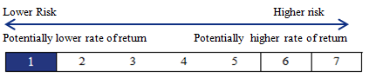

The rate of return and risk indicator is at a level 1. This indicator is calculated by carrying out performance simulations between the initial net asset value and the net asset value on the International Final Reference Date. This indicator does not reflect the risk profile or rate of return of a subscriber who might request redemption based on an early exit event. These simulations are performed on the basis of the historical fluctuation of the price of the Share.

The past performances of the share do not provide any indication of the future performances of the share. The risk category associated with this FCPE is not guaranteed and could change over time. The lowest risk category is not “risk free”.

On each net asset value calculation date (which typically occurs on a bi-monthly basis), this FCPE offers a guarantee on the capital invested plus a performance featuring a Leverage Mechanism linked to the fluctuation in the price of the Share.

**Guarantee:** Under the terms of an “Underwriting Agreement”, NATIXIS guarantees that the net asset value of the FCPE at the expiration date, or in the event of an early exit, will be equal to the Guaranteed Net Asset Value (subject to any tax, social security, or other assimilated withholdings).

# Fees

|  |  |  |
| --- | --- | --- |
| **Non-recurrent fees withheld prior to or after investing** | | |
| Fees upon subscription | | None |
| Fees upon redemption | | None |
| The percentage indicated is the highest percentage that can be withheld from your capital before it is invested. | | |
| Fees withheld by the FCPE on an annual basis | | |
| Recurrent Fees: | 1.06 % | |
| Fees withheld by the FCPE under certain circumstances | | |
| Performance commission | | None |

The variables used in the calculation of the Guaranteed Net Asset Value may be modified if any of the events and/or transactions described in the International Swap Agreement were to occur (as a result of, in particular, a delisting of the share, bankruptcy, nationalization, tender offer, or the early termination of the International Swap Agreement).

In exchange for benefiting from the guarantee on the amount of their personal contribution and, as the case may be, from the Performance, the unitholder waives his or her right to benefit from the 4.99 % discount, from a portion of the potential increase in the price of the Share, and from the potential receipt of dividends and other financial entitlements intended for shareholders (for further details please refer to the Regulations of the FCPE).

**Specific risks:**

- In certain cases of adjustment and termination of the International Swap Agreement and in certain cases of termination of the Underwriting Agreement described in the Regulations of the FCPE, the unitholder could receive an amount lower than the Guaranteed Net Asset Value for each unit he or she holds.

- Generally, the FCPE is exposed to a risk that NATIXIS defaults on its obligations as counterparty and as guarantor. As such, in the event that NATIXIS effectively defaults and in the event where the price of the Share has dropped significantly, the unitholder may receive an amount that is lower than the Guaranteed Net Asset Value or lower than his or her personal contribution.

The fees and commissions paid are used to cover the operational costs of the FCPE, including the distribution costs associated with the units. Such fees reduce the potential growth of the investments.

The percentage of recurrent fees provided hereto is an estimate. This percentage can vary from one year to the next. It does not include:

* performance commissions,
* brokerage fees, with the exception of subscription and redemption fees paid by the FCPE when it acquires or sells units of another UCI (Undertaking for Collective Investment).

For further information on the fees, please refer to the section entitled “Fees” in the prospectus of this FCPE, available on the website of the HIUA appointed by your company.

# Performance Scenarios

The examples presented hereunder are provided for the purpose of illustrating the formula. However, they do not represent a prediction of what could actually occur. It is hereby clearly stipulated that these various scenarios do not necessarily share the same likelihood of occurrence from one scenario to another. The performance scenarios are to be understood as occurring at expiration.

At expiration, the savings of each unitholder will be equal to the sum of his or her personal contribution plus the Performance times the number of units subscribed.

In the event that the Final Share Price is higher than the Reference Price, the calculation formula of the Performance at the International Final Reference Date is the following: (Variable Multiple) x (increase in the price of the Share), or :

C:\Users\ns25493\Desktop\Capture 1.PNG

The Participation Percentage is equal to 75% and the Leverage is equal to 10. In the examples presented hereunder, the Reference Price is set at EUR 21 (in other words, the Reference Price calculated on October 15, 2019), the Subscription Price (which corresponds to the initial value of a unit) is equal to EUR 19.95 and the personal contribution is equal to EUR 19.95, which enabled the subscription of one unit:

*Unofficial English translation of the French language document (July 2019)*

**Unfavorable case:** if the Final Share Price (calculated based on an average of 52 prices of the Share) is equal to EUR 16.5 it is lower than the Reference Price: therefore, the holder will receive the guarantee on his or her personal contribution, i.e. EUR 19.95. The annual rate of return of the personal contribution per unit is equal to 0 %.



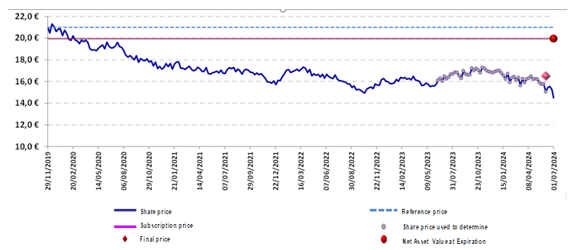

|  |  |
| --- | --- |
| (Assumption : no event triggering an adjustment or a correction has occurred) | Unfavorable Case |
| Example of the Final Share Price on the International Final Reference Date | 16.50 € |
| Net Asset Value of one FCPE unit on the International Final Reference Date | 19.95 € |
| Annualized performance of the Final Share Price compared to the Reference Price | -5.12 % |
| Annualized performance of the Net Asset Value compared to the personal contribution | 0.00 % |

**Median case:** if the Final Share Price (calculated based on an average of 52 prices of the Share) is equal to EUR 20.50, it is lower than the Reference Price: therefore, the unitholder will receive the guarantee on his or her personal contribution, i.e. EUR 19.95. The annual rate of return of the personal contribution per unit is equal to 0%.

|  |  |
| --- | --- |
| (Assumption : no event triggering an adjustment or a correction has occurred) | Median Case |
| Example of the Final Share Price on the International Final Reference Date | 20.50 € |
| Net Asset Value of one FCPE unit on the International Final Reference Date | 19.95 € |
| Annualized performance of the Final Share Price compared to the Reference Price | -0.52 % |
| Annualized performance of the Net Asset Value compared to the personal contribution | 0.00 % |

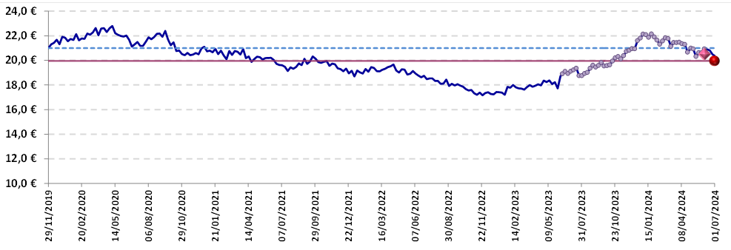



**Favorable case:** if the Final Share Price (calculated based on an average of 52 prices of the Share) is equal to EUR 26.00, it is higher than the Reference Price: in addition to the guarantee on his or her personal contribution (EUR 19.95), the unitholder will receive the Performance, representing a total of: 19.95 + (19.95 / 19.95)x [ (10 x 0.75 x 21) / (0.5 x 26 + 0.5 x 21) ] x (26 – 21) = EUR 53.46. The annual rate of return of the personal contribution per unit is equal to 23.94 %.

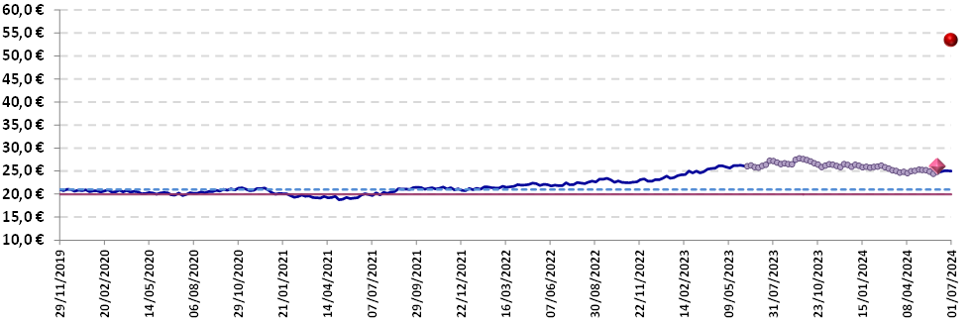



|  |  |
| --- | --- |
| (Assumption : no event triggering an adjustment or a correction has occurred) | Favorable Case |
| Example of the Final Share Price on the International Final Reference Date | 26.00 € |
| Net Asset Value of one FCPE unit on the International Final Reference Date | 53.46 € |
| Annualized performance of the Final Share Price compared to the Reference Price | 4.76 % |
| Annualized performance of the Net Asset Value compared to the personal contribution | 23.94 % |

# Useful Information

**Custodian**: BNP - Paribas Securities Services

**Holder of Individual Unitholders’ Accounts**: AXA EE

**Legal form**: individualized group FCPE.

This FCPE is created pursuant to the Plan d’Epargne Salariale International (PIAG) of the AXA Group, established by member companies and their employees on October 19, 2001, and its amendments, from which it is inseparable.

The most recent version of the regulations and regulatory documents disclosing periodic information for this FCPE and any underlying funds, as well as other useful information, are available free of charge from the management company.

**Location and terms and conditions applicable to obtaining the net asset value**: The net asset value is available upon request from the HIUA appointed by your Company.

**Periodic information of the company for the FCPEs invested in company securities**: www.axa.com

**Tax Treatment**: the legislation in force in the country of residence of the investor is the applicable legislation.

**Method of exercise of the voting rights attached to the securities**: Individual exercise by unitholders of the voting rights attached to the securities issued by the Company (AXA); the double voting rights attached to the AXA shares held by the FCPE are attributed to the FCPE and allocated to each unitholder; the fractional voting rights attached to fractions of units are exercised by the Supervisory Board.

**Supervisory Board**: The Supervisory Board of the FCPE reviews the management report and the annual financial statements of the FCPE, the financial, administrative, and accounting management of the FCPE, approves its annual report, and can present resolutions at the general shareholders’ meetings of the issuing company.

The Supervisory Board is comprised of 6 members:

- 3 permanent members who are both employees and unitholders representing unitholders who are either current or former employees

- 3 members representing the companies,

distributed according to the following geographic areas:

- Countries in the European geographic area: includes a total of 4 members

- Countries outside of the European geographic area: includes a total of 2 members (please refer to the description of the geographic areas detailed in the Regulations of the FCPE).

Due to the fact that the FCPE is an FCPE with compartments, the Supervisory Board must include at least one unitholder from each compartment.

**Liability Statement**: The liability of AXA Investment Managers Paris can only be engaged insofar as the statements contained in this document are misleading, inaccurate, or inconsistent with the sections to which they correspond in the Regulations of the FCPE.

This FCPE is approved in France and regulated by the *Autorité des Marchés Financiers* (French Financial Markets Regulator or “AMF”). AXA IM Paris is approved in France and regulated by the AMF. The key information provided herein to investors is accurate and current as of July 1st, 2019.

*Unofficial English translation of the French language document (June 2018)*