This document provides essential information to the investors of this Collective Employee Shareholding Fund (French Fonds Commun de Placement d’Entreprise, hereinafter referred to as “FCPE”). This is not a promotional document. The information contained herein is provided to you as required by law, in order to help you understand what investing in this FCPE means and what risks are associated with it. It is hereby recommended that you read it in order to make an informed decision on whether or not to invest.
MULTI ASSET CLIENT SOLUTIONS
AXA Shareplan Direct Global

Compartment of the Shareplan AXA Direct Global FCPE
Category of units: AXA SHAREPLAN DIRECT GLOBAL Capitalized in Euros (AMF CODE: 990000089419)
This FCPE is managed by AXA IM Paris, a subsidiary of the AXA IM Group
Fonds Commun de Placement d’Entreprise (French Collective Employee Shareholding Fund, or “FCPE”) - Fonds d’Epargne Salariale (French Employee Savings Fund) governed by French law

Investment Objective and Policy  The FCPE belongs to the following category: “Invested in publicly-traded securities of the company”.  Management objective  The management objective of this FCPE is to replicate the performance of the AXA share whether upwards or downwards.  Investment Policy  The portfolio of the FCPE is fully and exclusively comprised of AXA shares, excluding any liquid assets, which cannot exceed 5 % of the net assets. | Currency  Currency of reference of the FCPE: Euro.  Recommended investment term  This FCPE may not be suitable for investors who plan on redeeming their investment before a period of 8 years. Unitholders should note that this recommended investment term does not take into account the statutory lock-up period applicable to their savings, which corresponds to 5 years.  Terms and conditions applicable to subscription and redemptions  Contributions / Redemptions: in cash and/or in securities due to local legal and/or regulatory constraints in the countries concerned; based on the next net asset value calculated.  Terms and conditions applicable to early redemption requests and to redemption after expiration of a 5-year lock-up period.  Redemption requests, together with any supporting documentation, as the case may be, must be sent to the Holder of Individual Unitholders’ Accounts (the “HIUA”), if practical via the Company, before 12:00 (noon French time) on the Trading Day corresponding to the date of calculation of the net asset value. Any request that reaches the HIUA after this deadline will be carried out on the basis of the net asset value calculated on the following Trading Day.  Unitholders can request to set a price floor for the AXA share when submitting their redemption request.  The net asset value is calculated on each Trading Day, with the exception of legal holidays in France and any days on which the Euronext Paris stock exchange does not close at its regular closing times.  Allocation of revenues: Capitalization
Unofficial English translation of the French language document (July 2019)

Risk profile and rate of return
At lower risk
Potentially lower rate of return
At higher risk
Potentially higher rate of return
potentially higher

1 | 2 | 3 | 4 | 5 | 6 | 7
Historical data, such as those used to calculate the synthetic indicator, may not constitute a reliable indication of the future risk profile of the FCPE.
The risk category associated with this FCPE is not guaranteed and could change over time.
The lowest risk category is not “risk free”.
Why is the FCPE in this category?
The FCPE does not provide a capital guarantee. It is invested in markets and/or uses techniques or instruments that could face rapid and significant fluctuations, which in turn could lead to sizable gains or losses.
The risk indicator of this FCPE is representative of its exposure to the Company’s shares.
Important risks which are not taken into account in the risk indicator
None

AXA Shareplan Direct Global
Fees  The fees and commissions paid are used to cover the operational costs of the FCPE, including the commercialization and distribution costs associated with the units. Such fees reduce the potential growth of the investments.  Non-recurrent fees withheld prior to or after investing  Fees upon subscription 0.20%  Fees upon redemption None  The percentage indicated is the highest percentage that can be withheld from your capital before it is invested.  Fees withheld by the FCPE on an annual basis  Recurrent Fees 0.23 %  Fees withheld by the FCPE under certain circumstances  Performance commission None | Recurrent fees are based on the expenses incurred over the course of the past 12 months leading up to December 2018. This percentage can vary from one year to another. It does not include:  - performance commissions,  - brokerage fees, with the exception of subscription and redemption fees paid by the FCPE when it acquires or sells units of another UCITS (Undertaking for Collective Investment in Transferable Securities), AIF (Alternative Investment Fund) or other investment vehicle.  For further information on the fees, please refer to the section entitled “Fees” in the prospectus of this FCPE, available on the website of the HIUA appointed by your Company
Past Performances  AXA Shareplan Direct Global Capitalisation EUR (990000089419)  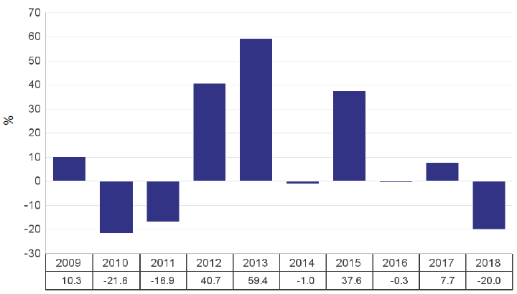 | The past performances of the share do not provide any indication of the future performances of the share.  The performances presented above are net of all fees. Subscription and redemption fees are not included in the performance figures.  This FCPE was created on 09/13/2005.  Past performances are calculated in Euros and are expressed as a percentage of the net asset value of the FCPE at the end of each year.

Useful information  Custodian: BNP-Paribas Securities Services  Holder of Individual Unitholders’ Accounts: AXA EE  Location and terms and conditions applicable to obtaining the net asset value: The net asset value is available upon simple request to the HIUA appointed by your Company.  Tax Treatment:  French legislation applies to investors who are residents of France for tax purposes. The tax legislation in force in France and the tax legislation in force in the country of residence of the investor are applicable.  Liability Statement: The liability of AXA Investment Managers Paris can only be engaged insofar as the statements contained in this document are misleading, inaccurate, or inconsistent with the sections to which they correspond in the regulations of the FCPE. | Supervisory Board:  The Supervisory Board of the FCPE reviews the management report and the annual financial statements of the FCPE, the financial, administrative, and accounting management of the FCPE, approves its annual report, and can present resolutions at the general shareholders’ meetings of the issuing company. The Supervisory Board is comprised of 6 members:  - 3 permanent members who are both employees and unitholders representing unitholders who are either current or former employees  - 3 members representing the companies; spread out according to the following geographic locations:  - Countries in the European zone: with a total of 4 members for countries in the European zone;  - Countries outside of the European zone: with a total of 2 members for countries outside of the European zone (please refer to the breakdown per zone in the regulations of the FCPE). Due to the fact that the FCPE is an FCPE with compartments, the Supervisory Board must include at least on unitholder from each compartment.  Periodic information of the company for the FCPEs invested in company securities: www.axa-im.com  Method of exercise of the voting rights attached to the securities:  The unitholders individually exercise the voting rights attached to the securities issued by the Company or by any company related to it in the meaning of the second paragraph of Article L. 3344-1 of the French Labor Code. The double voting rights attached to the AXA shares, if applicable, held by the FCPE are attributed to the FCPE and allocated to each unitholder in proportion to the number of units the latter holds. The fractional voting rights attached to fractions of units are exercised by the Supervisory Board, which for that purpose appoints an officer representing the FCPE at the general shareholders’ meetings of the issuing company.  Legal form: individualized group FCPE.  The most recent version of the regulations and periodic regulatory information documents of this FCPE, as well as other useful information, are available free of charge from the management company.

